1. 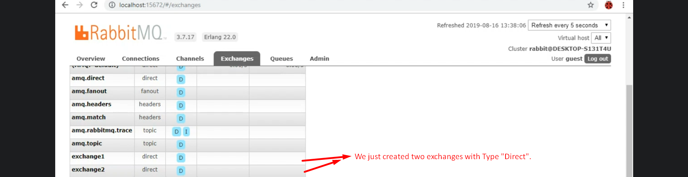
2. 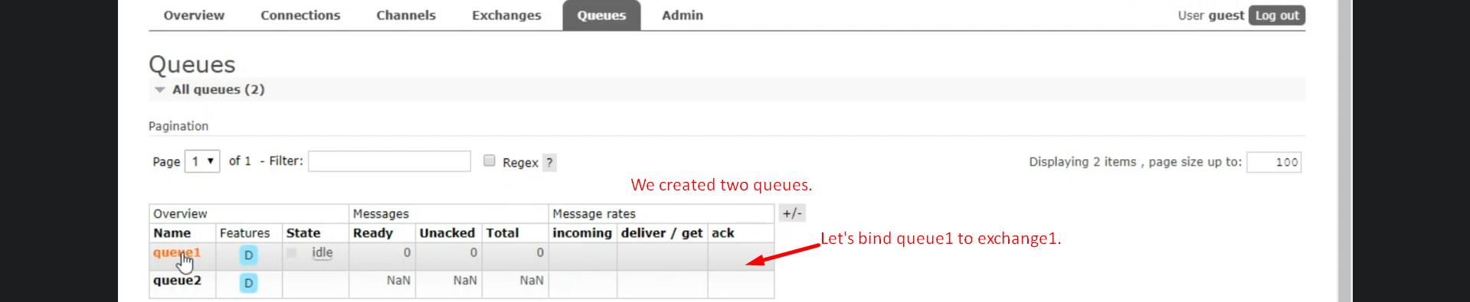
3. 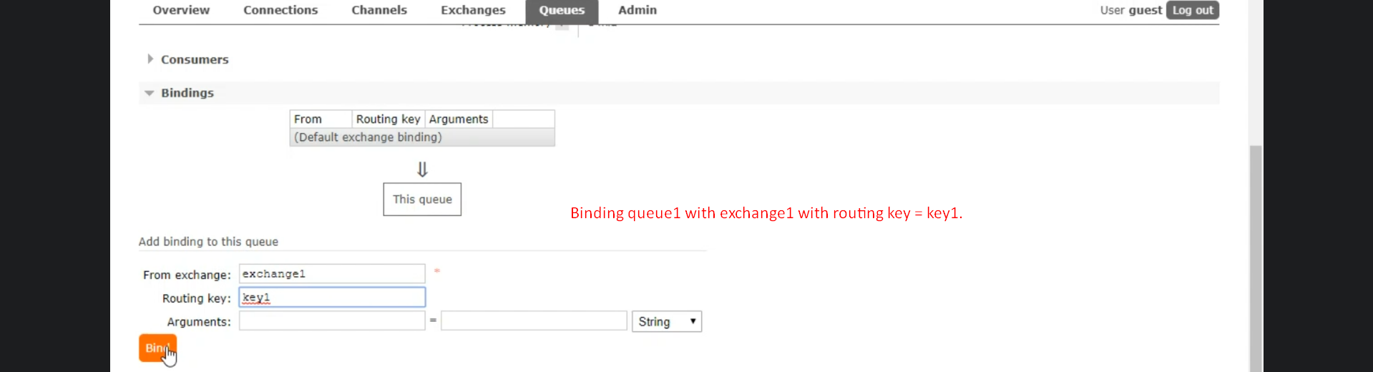  
   
4. 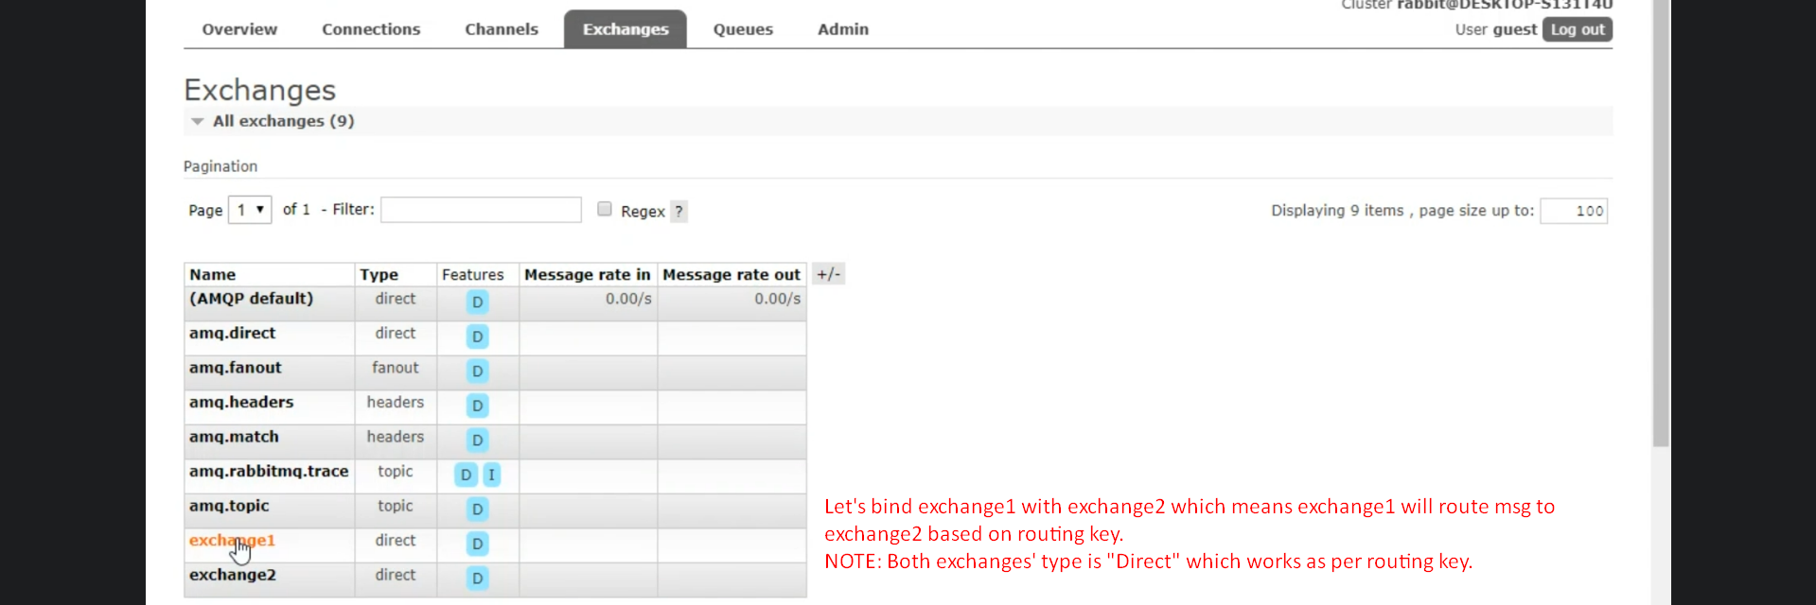
5. 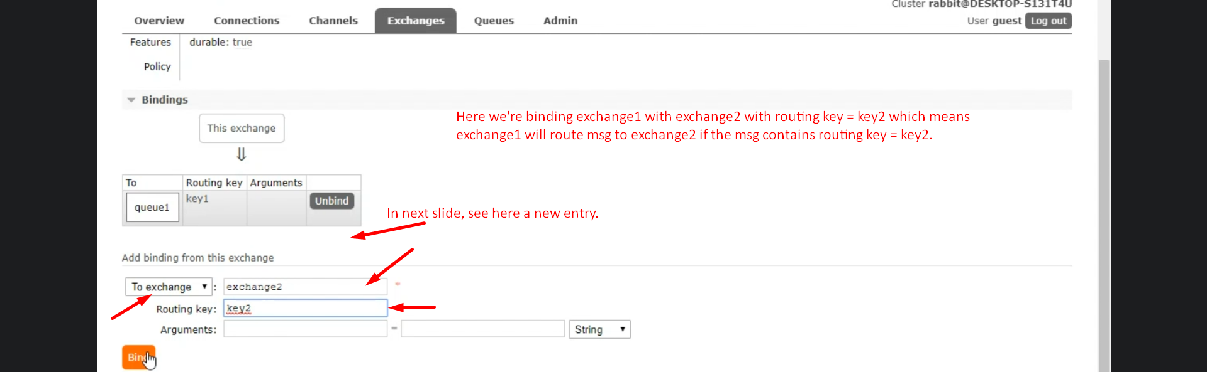
6. d

|  |  |  |
| --- | --- | --- |
| Exchange1 bound to | Queue1 | Routing key = key1 |
| Exchange2 bound to | Queue2 | Routing Key = key2 |
| Exchange1 bound to | Exchange2 with | Routing Key = key2 |

Now, say we’re publishing msg to Exchange1 with routing_key=key2.   
See Exchange will route this msg to Exchange2 based on routing key = 2 and Exchange2 will route this msg to Queue2. See the below slide.

